1. 题目

04148: 生理周期

brute force, http://cs101.openjudge.cn/practice/04148

代码：

num = 1  
while True:  
 p, e, i, d = map(int, input().split())  
 if [p, e, i, d] == [-1, -1, -1, -1]:  
 break  
  
 s = d + 1  
  
 while (s-p)%23!=0 or (s-e)%28!=0 or (s-i)%33!=0:  
 s += 1  
  
 s -= d  
 print(f'Case {num}: the next triple peak occurs in {s} days.')  
 num += 1

代码运行截图 （至少包含有"Accepted"）

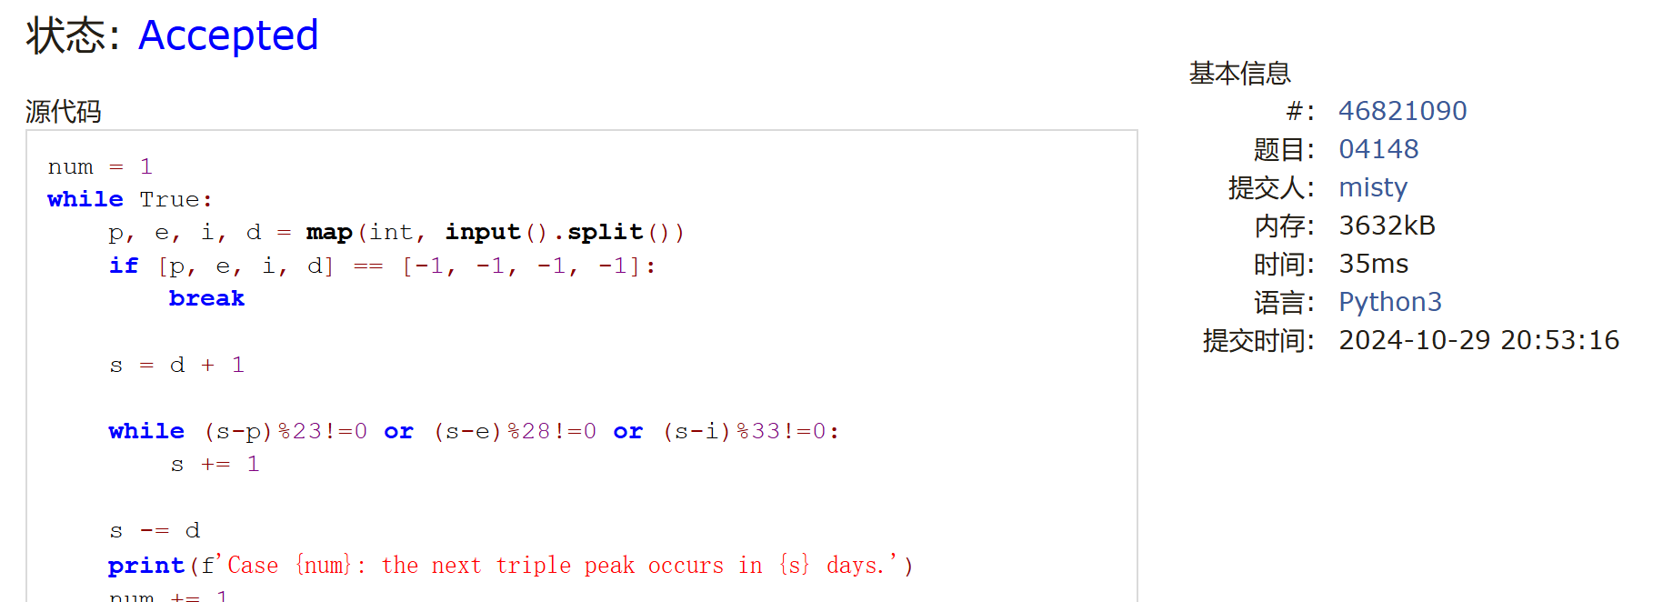

18211: 军备竞赛

greedy, two pointers, http://cs101.openjudge.cn/practice/18211

代码：

p = int(input())  
cost = sorted(list(map(int, input().split())))  
  
i, j, cnt = 0, len(cost) - 1, 0  
  
while i < j:  
 if cost[i] <= p:  
 cnt += 1  
 p -= cost[i]  
 i += 1  
 elif cnt !=0:  
 cnt -= 1  
 p += cost[j]  
 j -= 1  
 else:  
 break  
  
print(cnt + (cost[i] <= p))

代码运行截图 ==（至少包含有"Accepted"）==

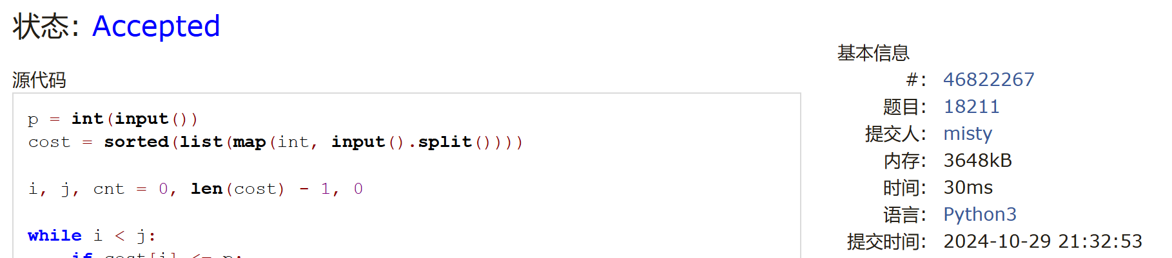

21554: 排队做实验

greedy, http://cs101.openjudge.cn/practice/21554

代码：

n = int(input())  
time = list(map(int, input().split()))  
students = sorted([(time[i], i + 1) for i in range(n)])  
print(" ".join(map(lambda stu: str(stu[1]), students)))  
pre_sum, total = 0, 0  
for stu in students:  
 total += pre_sum  
 pre_sum += stu[0]  
print(f"{total/n:.2f}")

代码运行截图 （至少包含有"Accepted"）

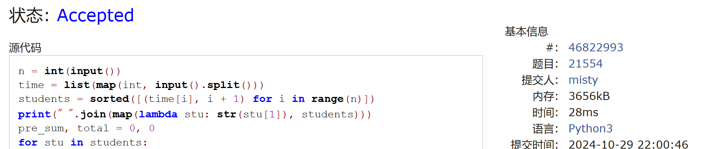

01008: Maya Calendar

implementation, http://cs101.openjudge.cn/practice/01008/

代码：

Haab = {"pop": 0, "no": 1, "zip": 2, "zotz": 3, "tzec": 4, "xul": 5, "yoxkin": 6, "mol": 7, "chen": 8, "yax": 9, "zac": 10, "ceh": 11, "mac": 12, "kankin": 13, "muan": 14, "pax": 15, "koyab": 16, "cumhu": 17, "uayet": 18}Tzolkin = {0: "imix", 1: "ik", 2: "akbal", 3: "kan", 4: "chicchan", 5: "cimi", 6: "manik", 7: "lamat", 8: "muluk", 9: "ok", 10: "chuen", 11: "eb", 12: "ben", 13: "ix", 14: "mem", 15: "cib", 16: "caban", 17: "eznab", 18: "canac", 19: "ahau"}n = int(input())print(n)for _ in range(n):

day, month, year = input().split()

day = int(day.rstrip("."))

total = int(year) * 365 + Haab[month] * 20 + day

print(total % 13 + 1, Tzolkin[total % 20], total // 260)

代码运行截图 （至少包含有"Accepted"）

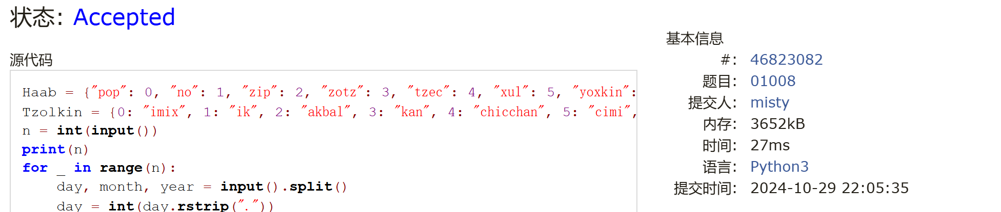

545C. Woodcutters

dp, greedy, 1500, https://codeforces.com/problemset/problem/545/C

代码：

n = int(input())s = [[int(x) for x in input().split()] for i in range(n)]count = 2if n == 1:

print(1)else:

for i in range(1, n-1):

if s[i][0] - s[i-1][0] > s[i][1]:

count += 1

elif s[i+1][0] - s[i][0] > s[i][1]:

count += 1

s[i][0] += s[i][1]

print(count)

代码运行截图 （至少包含有"Accepted"）

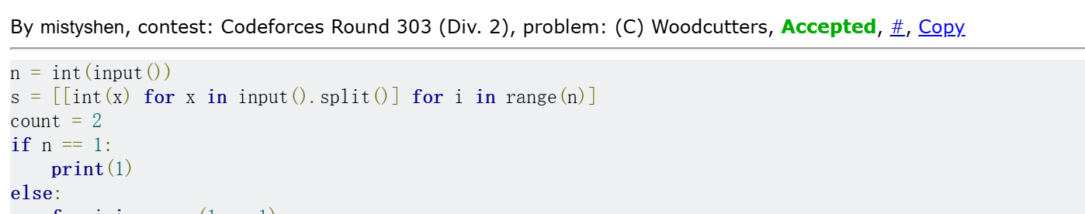

01328: Radar Installation

greedy, http://cs101.openjudge.cn/practice/01328/

代码：

import math  
  
def solve(n, d, islands):  
 if d < 0:  
 return -1  
  
 ranges = []  
 for x, y in islands:  
 if y > d:  
 return -1  
 delta = math.sqrt(d * d - y * y)  
 ranges.append((x - delta, x + delta))  
  
 if not ranges:  
 return -1  
  
 ranges.sort(key=lambda x:x[1])  
  
 number = 1  
 r = ranges[0][1]  
 for start, end in ranges[1:]:  
 if r < start:  
 r = end  
 number += 1  
  
 return number  
  
case_number = 0  
while True:  
 n, d = map(int, input().split())  
 if n == 0 and d == 0:  
 break  
  
 case_number += 1  
 islands = []  
 for _ in range(n):  
 islands.append(tuple(map(int, input().split())))  
  
 result = solve(n, d, islands)  
 print(f"Case {case_number}: {result}")  
 input()

代码运行截图 （至少包含有"Accepted"）

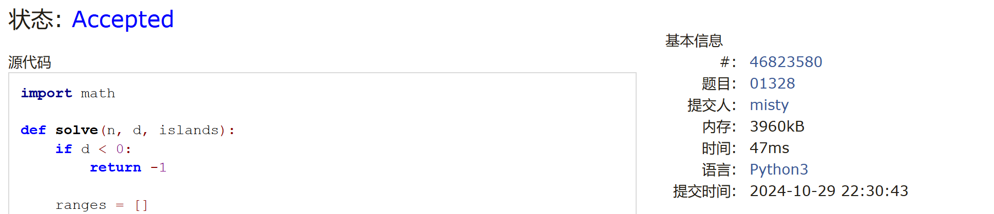

1. 学习总结和收获
2. 第三题和最后一题看答案都看了好久，自己想基本没有思路，看答案代码也要理解很久。
3. 这次作业难度比上次高了很多，但是很快要考高数和有机期中了，等期中考完得恶补一下。
4. 英文的题干一长就容易看不懂
5. 有些小细节即使学过也很快就忘，比如Maya日历一题中的.rstrip(".")